A tribute to Max Carter >>>
The following is my tribute to Max Carter taken from a time period when we both worked on the Replica Scow Project for Hobson Wharf Maritime Museum.
(The below illustration is from their log magazine published during this time period)

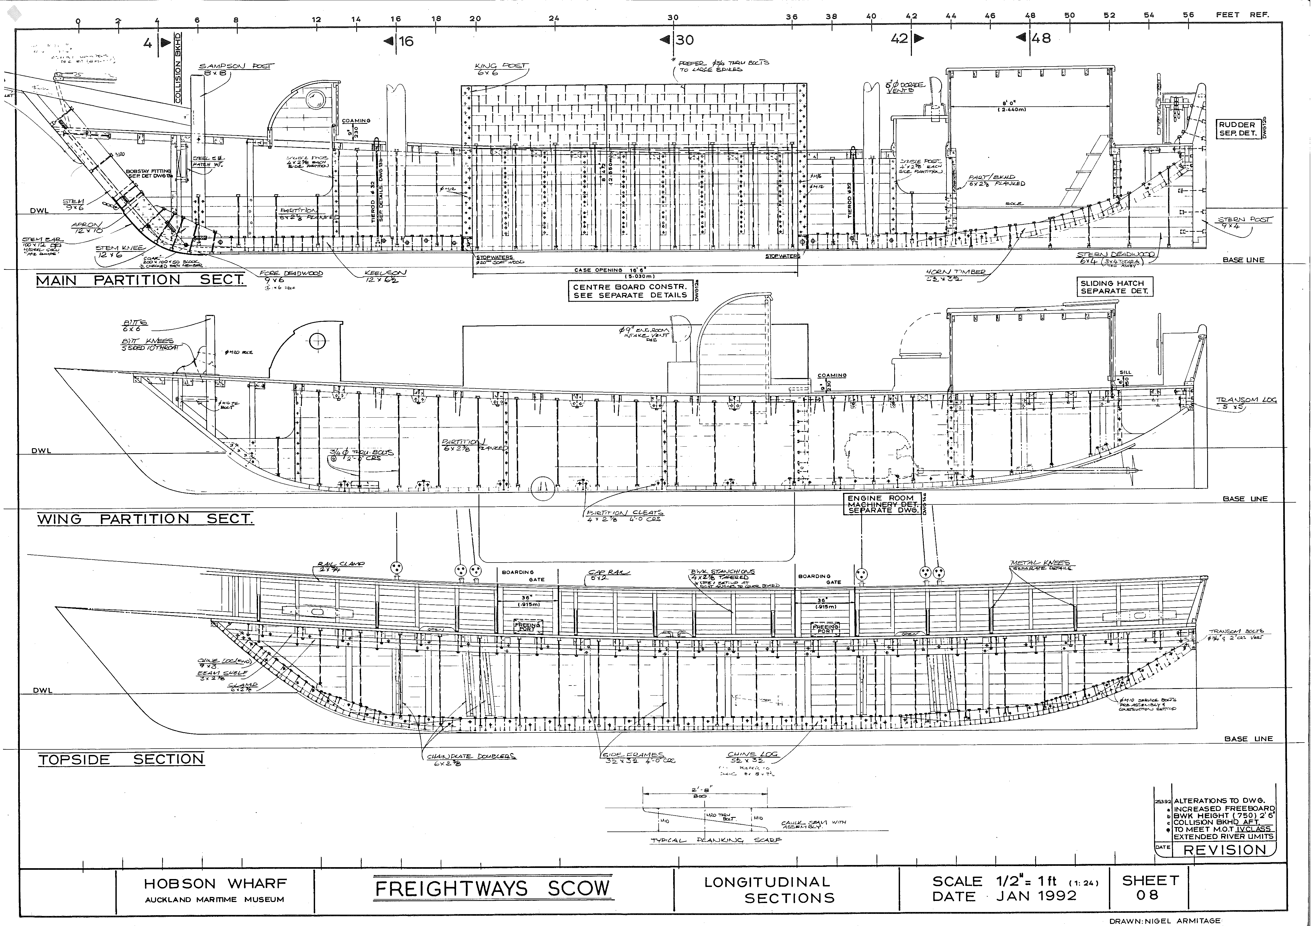

Max always referred to himself as a ‘Shipwright’ and so was naturally in his element with the supervision and construction of the Scow!
Max was instrumental in ensuring that ‘old time’ methods of construction were used wherever possible. As the Scow was being built to survey – there were some compromises that had to be made at times to ensure that we kept within the Marine Survey standards applicable at the time.
For those of us fortunate to work on the construction of this vessel – it surely was an enlightening experience. There was also a regular group of older volunteers from various aspects of the maritime industry who would come and help out – all with a wealth of knowledge adding to the pleasurable experience that this project was.

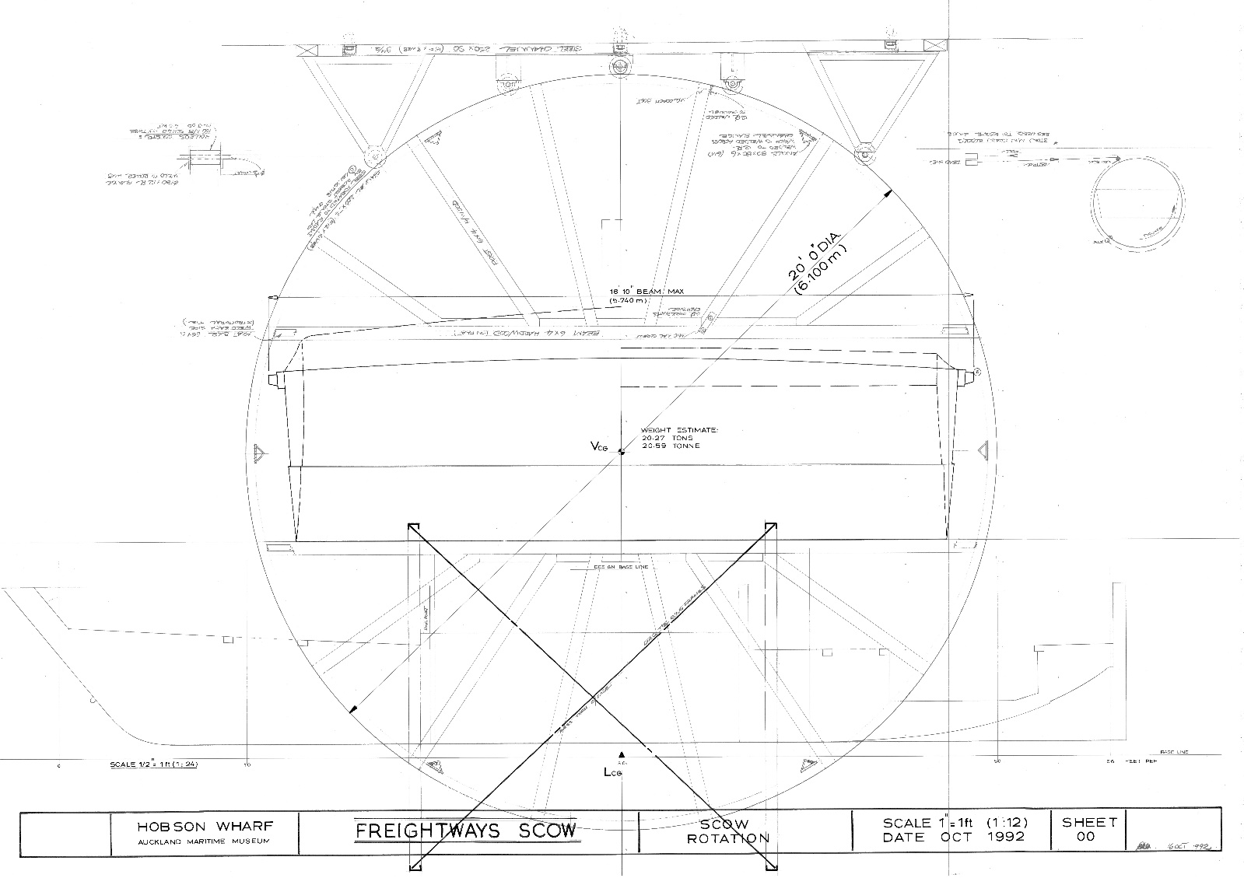
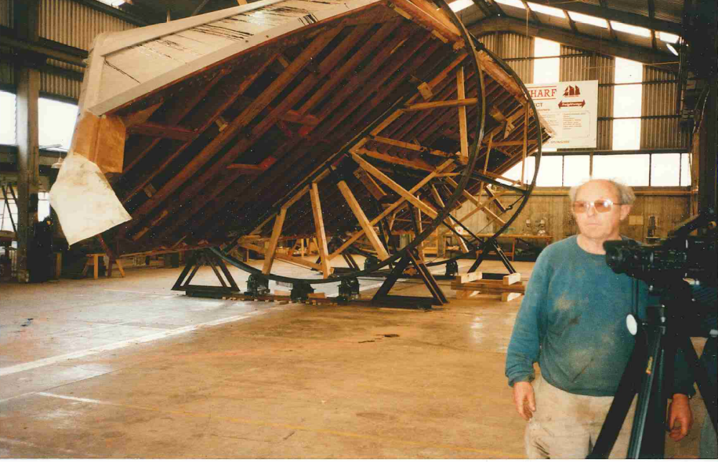
Max at the forefront of the rotation of the scow – a piece of engineering in its own right! Max was great at pioneering this type of problem solving – new traditions over old traditions – need we say more!
(Diagram above shows the principle of rotation used)

Typical sketch with some detail that Max would do – these would then be incorporated into detailed working drawings.

An example of the end result (i.e. working drawings) – this gave me personally the greatest satisfaction relating to working with Max.

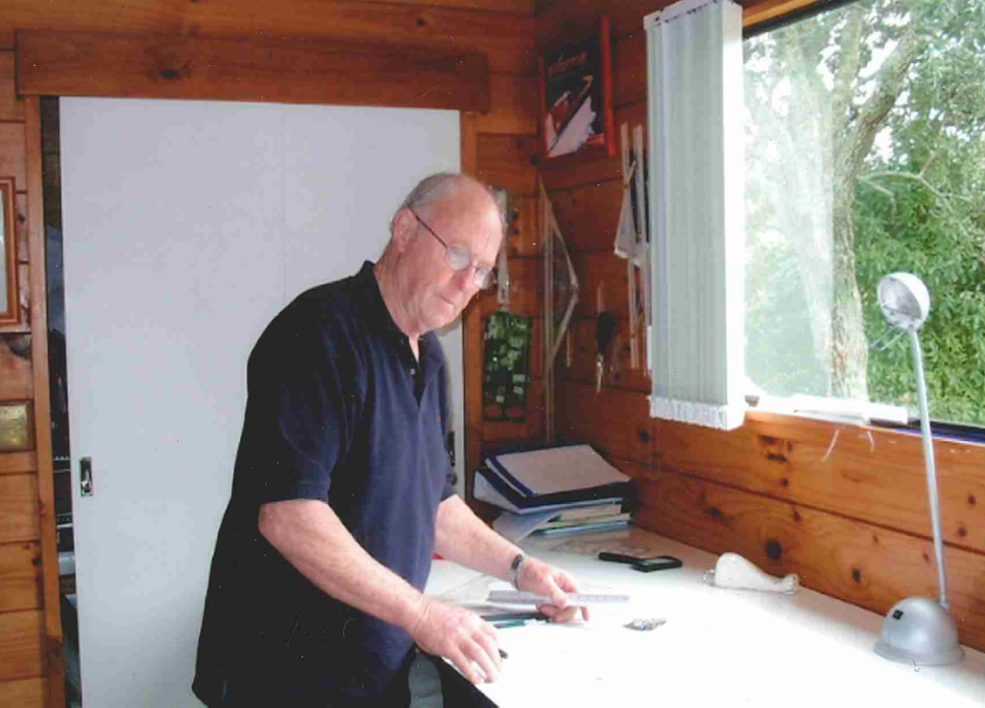

This is Max as I like to remember him – busy nutting out construction detail work. His engineering of woodworking projects was incredible – not always easy to interpret onto paper.

Old style methodology that Max was capable of dipping into and bringing into projects was amazing – a lot of this was derived from his large book collection but you still had to be able to interpret it into something viable for a project and practical through to the shop floor. It is getting harder and harder to find people who have ability to mentor nowadays – especially people of Max’s calibre.

Rest in Peace Old Timer >>>>

Nigel Armitage
E: armitagedesign@xtra.co.nz
M: 021 1424 236
Now living in Tauranga

